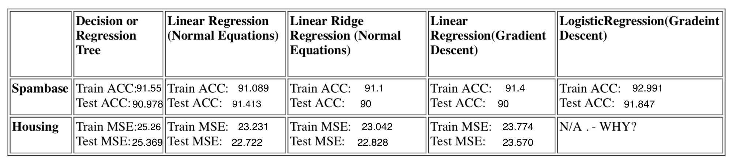

Logistic regression is for binary classification and cannot be applied to continuous data, thus it is not applicable on the housing data set. Logistic regression makes use of sigmoid function to limit the function between 0 and 1 boundaries to suit the binary target variable.